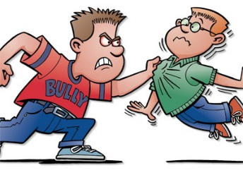
Brant Jacobs
Persuasive Essay
Cause and Effect/Problem and Solution
We Need To Stop Bullying!

In my opinion, bullying can affect everyone, those who are bullied, those who bully, and those who witness bullying. The problem is the bully doesn’t know that he is bullying the kid because he thinks he is just joking around. So while the kid knows he is being bullied the bully doesn’t know that, and goes on about his day, since he thinks he did nothing wrong. People usually over look this and do not do anything about it, you might think this is bias but I KNOW this is true! If you have ever seen this happen (bystander) you should speak up and tell the bully to stop and ask the kid if he is ok.

We have justified our way to stop bullying and it’s very simple…. And all you have to do is put up some posters around the school saying to stop bullying! People who get bullied have had impacts on mental health, suicide, and usurp drugs. People who stand by and watch bullying happen to have problems like skipping school or depression. Then, finally the bully can also have problems too, like abusing drug use, getting into fights, and engages in early sexual activity. So step up to help this cause, because of how many people bully, get bullied, and watch bullying happen.

Types of Bullying and What They Are

The three main ways to bully someone is cyber, physically, and verbally. Cyber bullying happens when somebody uses bad language or any language at all to bully someone else on the internet or any social media. Another way is by physically hurting or abusing someone else smaller or weaker that can’t fight back. Finally, the last way is by speaking to someone badly and saying things to hurt someone else’s self-esteem. We need to divert the bully’s action and let him change his ways. This is why we NEED to stop bullying around the country.

If you are a bully and you think it is ok to do this because it’s not hurting anyone besides the kid your bullying, but you are! In most cases during a school shooting the shooter has had a background of being bullied and can hurt a lot of other people in the process. You should be the first person to stop and promote august to other bullies for your kind acts. If you are a bully you should stop and tell the person sorry for what you have done or said. If you stop being a bully you can stop a whole chain of events from happening. So just stop and think what kinds of things you have said to them and just say sorry.

As a matter of fact, bullying is a big issue in the United States. Bullying is bad for the bully, bullied, and bystander in many ways. The person being bullied usually takes it the worst including suicide and usually get into drug use. On the other hand it would be easy to stop bullying at the source by seeing a bully in action and just say stop! So please join the group to stop bullying! You should show cited text of info you found about bullying and create your own posters. You should really try to pervade the message about bullying around your school to help! This is the reason bullying is one of the greatest problems in America

